“Demonsional: Stay Until Tomorrow”

Game Design Document Developed by Trystyn O’Haver

11/20/2022

Art 502

Table of Contents
- Game Goals
- Story Overview
- Licensor points and concerns
- Ethical Considerations
- Similar Competitive Products
- Game Controls
- Technological requirements
- Front end of the game
- Title/Start Screen
- Game flow chart
- Loading Screen
- Game camera(s)
- HUD system
- Player Characters (Hero's journey), NPCs that help
- Player Metrics
- Player Skills/Tech Tree of how skills unlock
- Player Inventory tools
- Combat/Conflict
- Health and related if applicable (alt states, lives, death, checkpoints)
- Scoring if applicable (Leaderboard setup and achievements)
- Rewards and economy
- Collectibles/object sets asset list
- World Overview/level select/Navigation screens
- Universal game mechanics
- Game Levels
- General enemy rules
- Level-specific enemies
- Bosses
- Minigames
- Cutscenes
- Music and SFX
- other screens (such as credits and bonus materials)
- Works Cited/Glossary
- Appendix(es)

Game Goals
This game is an allegorical experience that forces the player to experience different mental illnesses through the eyes of the character. It subverts uses an escape from reality and a role-playing game trope. This prototype version has the user play as Lethia Huxley (aka Sarah Huxley). Lethia will complete tasks given to her by the underworld that become darker in morals throughout the game. Her choices and interactions with objects and other characters progresses the play and story. Lethia is unique in her choice game play. Future prototype versions would expand gameplay time by the addition of stories/character to play through. The prototype is created for PC but may expand to consoles such as PlayStation or Xbox.

Story Overview
Located in a small town in 1980s America, Lethia also known as Sarah, is a spine-chilling yet odd teenager. Lethia lives in a small mobile home park outside of a major city. She spends her days struggling through her everyday life since her mother abandoned her and her father a year prior. Through this trauma Lethia has dealt with the everyday torment of her father’s drug abuse and her distain for reality. This growing distaste for life has brought Lethia to her final moments in this world. It is in this moment she is offered a deal. All sorrows in her life to be washed away for her soul and agreement to work with the underworld. Lethia agrees to this deal and uses her newfound powers to complete the tasks given to her by her new unknown “boss”. Slowly learning her new skills Lethia travels to various versions of reality she calls Ultralems, to complete horrendous tasks. These tasks however keep growing in horror throughout Lethia’s experience with them only getting darker and darker. Lethia notices her world getting darker as well. She slowly starts to notice the deal has not been kept up on the underworlds side. Her depression and horrors of her everyday life have only become worse. The terrors she dealt with before having become dreadful trepidations that have made her life worse. Lethia then is put in to place to determine if her world is worth saving or if her newfound life is worth living.

Marketing/Audience
The demographics of this target audience would be best described as adults of any gender. Their age range would most likely fall between 18–40-year-olds. Regarding geographics the target audience would most likely be in South America due to the story being based in 1980s America. The psychographic so this target audience would be audiences that understand and are accepting to a disrupt is social norms, for example religious trauma, childhood traumas etc.

Licensor points and concerns
Role playing games are a typical game trope with no licensor concerns. Since the character and assets are original to this game and developer so there are no other licensing issues.

Ethical Considerations

This game covers many topics that could be considered ethical considerations. The first to discuss would be the main characters suicide attempt. Something this drastic tends to be viewed as a negative rather than a learning and discussion point for the story. Another area would be the game having topics discussing drug and alcohol addiction. These are areas most of the geographic target audience may relate to on a personal level due to the current pandemic across America. The last ethical area that should be considered would be the main character in acting with the dark forces of the other world both by selling her soul and doing their biding.

Similar competitive products
- Sally Face
- Alice: Madness Returns
- Life is Strange
- Tell Me Why

Game Controls
The player will use the arrow keys to navigate Lethia throughout the game. The player will use general keyboard commands to attack, jump, dash, and combine commands depending on attach style choice or ability.

Technological requirements
This game requires access to a standard PC, Mac, or laptop. It is intentionally not hardware intensive. It is designed to be accessible regardless of device or internet connection.

Front end of the game
The Unity Game Development engine will be utilized for the design and development of this prototype.

Title/Start Screen
This game will have a general start screen to allow the players to change settings, select saved file, and start/continue game. The screen will be animated and start through and background animation of Lethia’s fight both physically and mentally.

Game flow chart

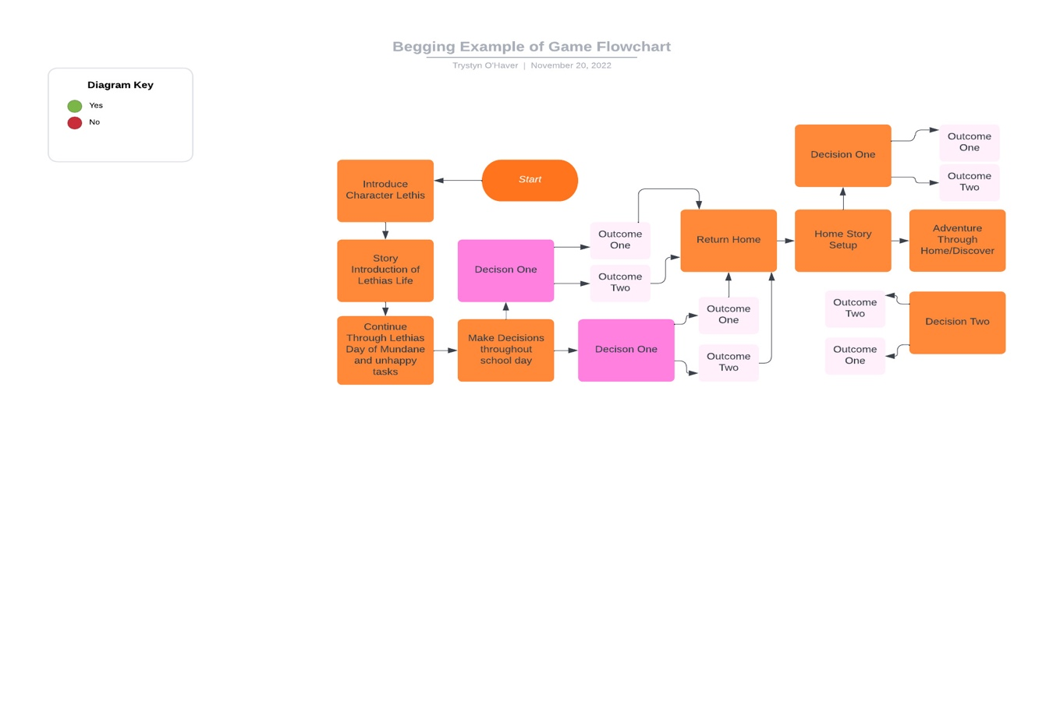

Loading Screen
In this prototype the loading screen will consist of a simple animated screen used throughout the game. It will show art based on gameplay. In the final’s development of the game, the loading screen will show a variety of loading animations and photos depending on where the player is at throughout the game. The final prototype will also give players game hints or advice.

Game camera(s)
This games perspective cameras will place the game play in three-dimensional world. The game will continue through three-dimension no matter the action being shown in the game. This perspective style will change depending on game type throughout the level Lethia is completing.

HUD system
The HUD system displays Lethia’s health bar, inventory, save, settings, objective or accepted tasks and exit.

The interface will show the settings located in the top left as well as the characters inventory. The characters health, stamina and objective will be in the bottom right.

Player Characters (Hero’s journey), NPCs that help
In this prototype, the only playable character is Lethia. NPCs that help are in each area.

Father- Beginning of story located in Lethia’s home
Neighbor 1- outside in trailer park
Neighbor 2- outside in trailer park
Neighbor 3- outside in trailer park
Landlord – Located in their home in trailer park or move to outside in trailer park

Student 1- Lunchroom
Student 2- Lunchroom
Student 3- classroom
Student 4- classroom
Student 5- classroom
Student 6-10- hallway
Teacher 1-4- located in classroom, lunchroom, hallway, and gym
Friend- Art classroom
Janitor- auditorium

Demons- Located throughout entire game
NPC characters you encounter in tasks- located throughout each level

Player Metrics
All areas of the map are at normal proportions with Lethia depending on game style change throughout each level.

Player Skills/Tech Tree of how skills unlock
The player interacts with NPC, Enemy characters, and items to unlock abilities. The character will unlock abilities and build on one of three ability trees techniques.

Player Inventory tools
Items the player could add to their inventory include a variety of items such as weapons, quest assets and puzzle collections.

Combat/Conflict
The characters combat will only encounter in quest level completion and boss battles. The character however can commit to conflict on any player decision choice the twill later impact the characters abilities and story for a brief time.

Health and related if applicable (alt states, lives, death, checkpoints)
Lethia’s death scenes will cause player to go back to most recent checkpoint as well as well as cue death scene of Lethia falling to the ground with a tear in her eye. As Lethia’s health declines she will start limping and slowing down.

Scoring if applicable (Leaderboard setup and achievements)
Completed Journal collection
Completed instruction book by boss collection
Complete each level side quest
Kill all bosses
Make all good decisions
Make all bad decisions

Rewards and economy
Certain items are needed to be collected to complete tasks. There are also items and side quests to complete that will give the player outside rewards for the characters abilities. The player has no economic value other than collecting points to build towards skill tree.

Collectibles/object sets asset list
Book pages
Journal pages
Weapons
Lights
Collect gilded bats for small rewards
Collect demon points throughout quests completions.

World Overview/level select/Navigation screens
The world over map will change depending on Lethia’s location such as being in the trailer park and the school. The level select is not an option in this game, but the player will have an option to select quests depending on what they have picked up.

Universal game mechanics
Walk with arrows. Select NPC conversation with objects and npcs to activate. Press x to escape.

Game Levels
These are initial concept sketches.

L1: Trailer Park
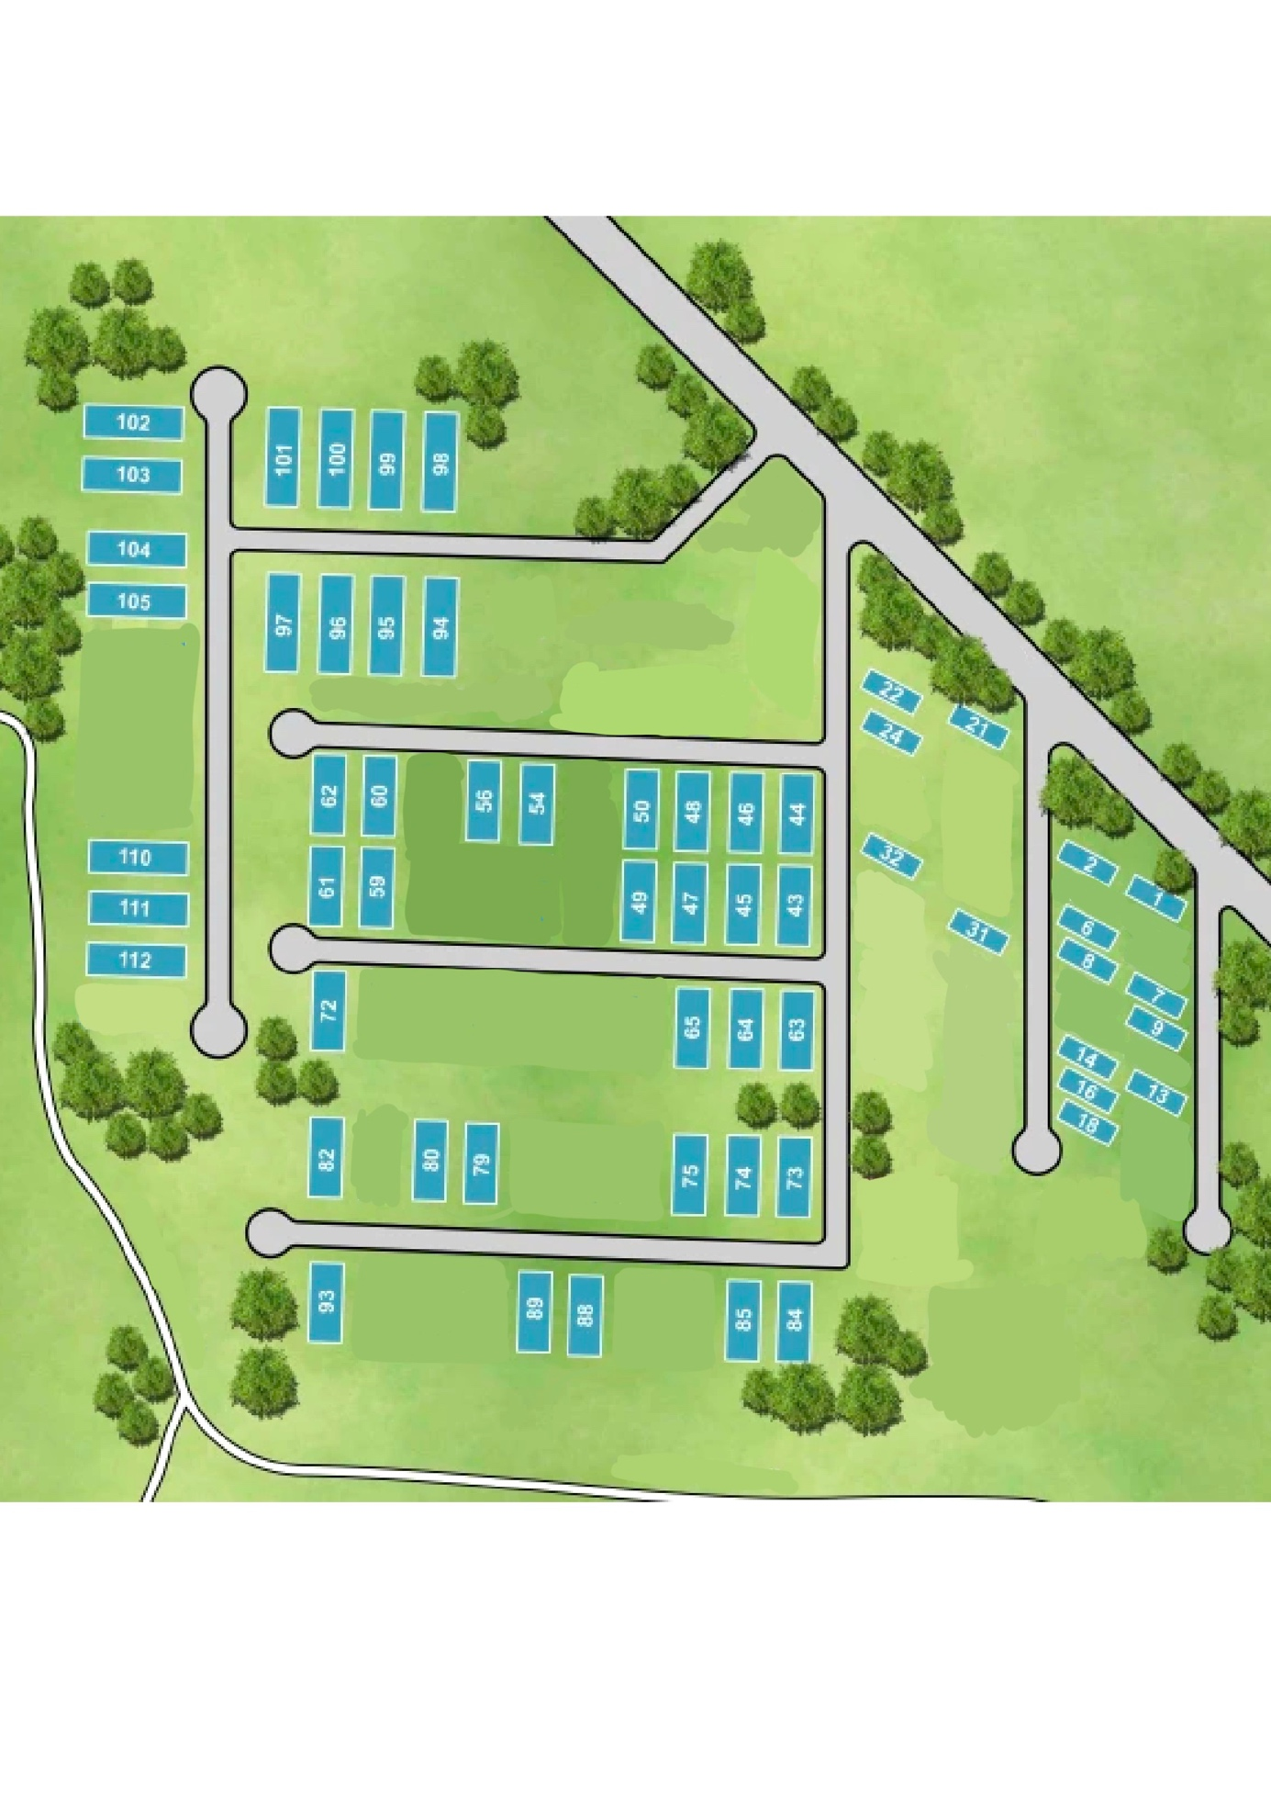

L2: School
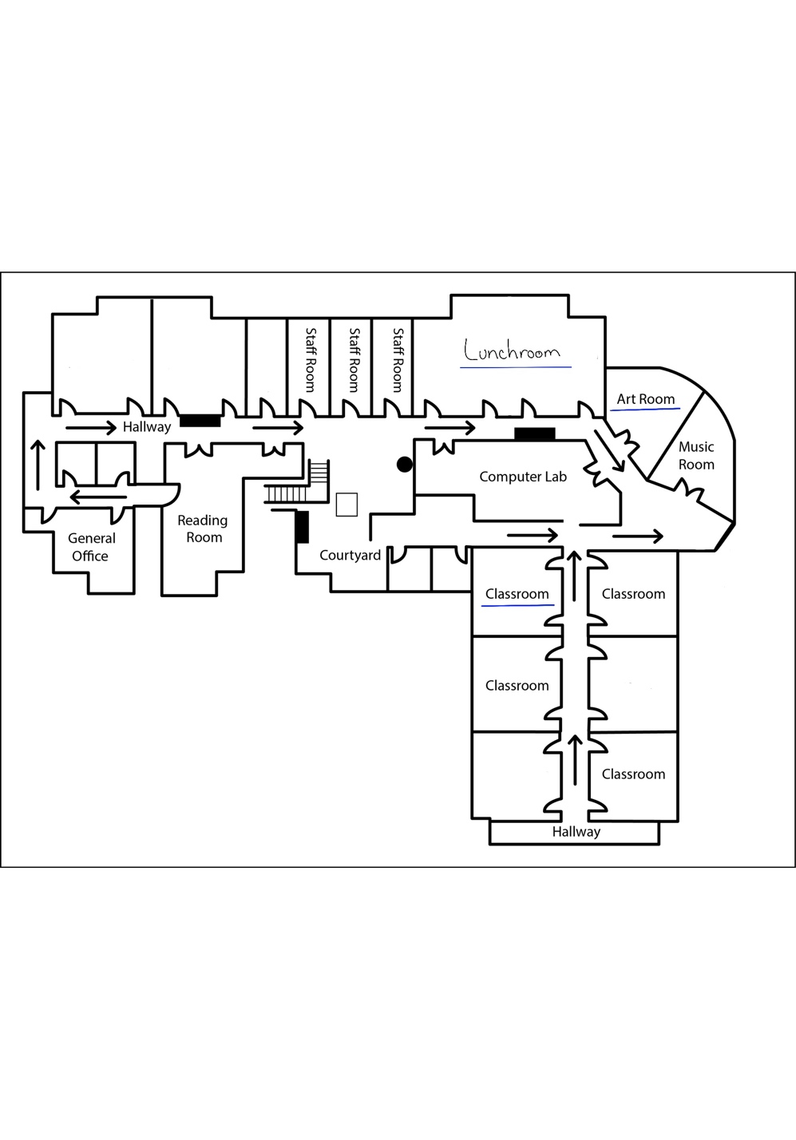

L3: Portal/ Level Entrance
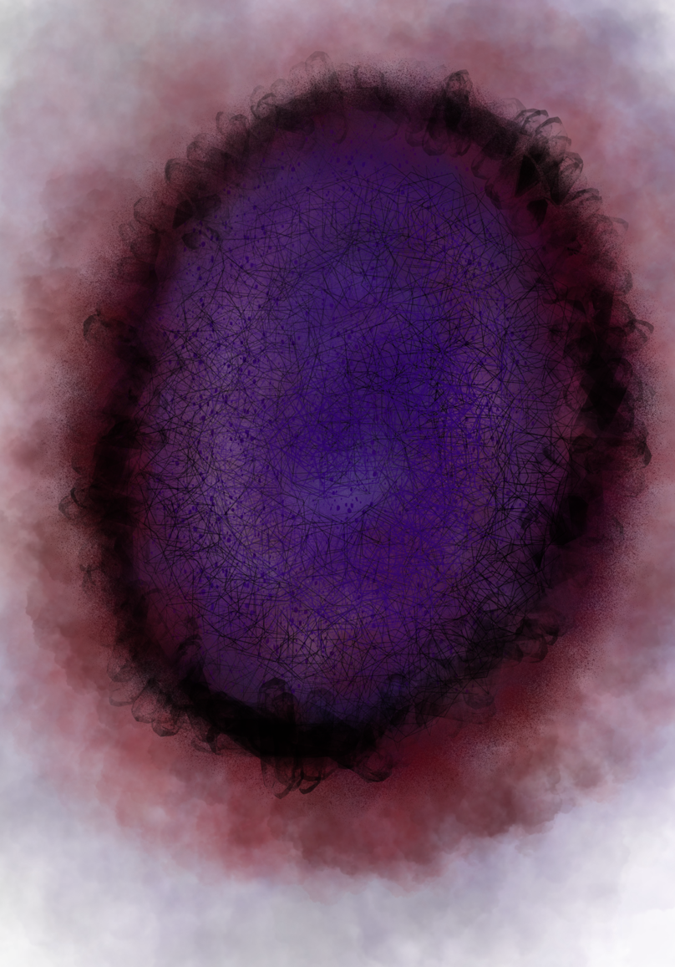

Loading Screen:
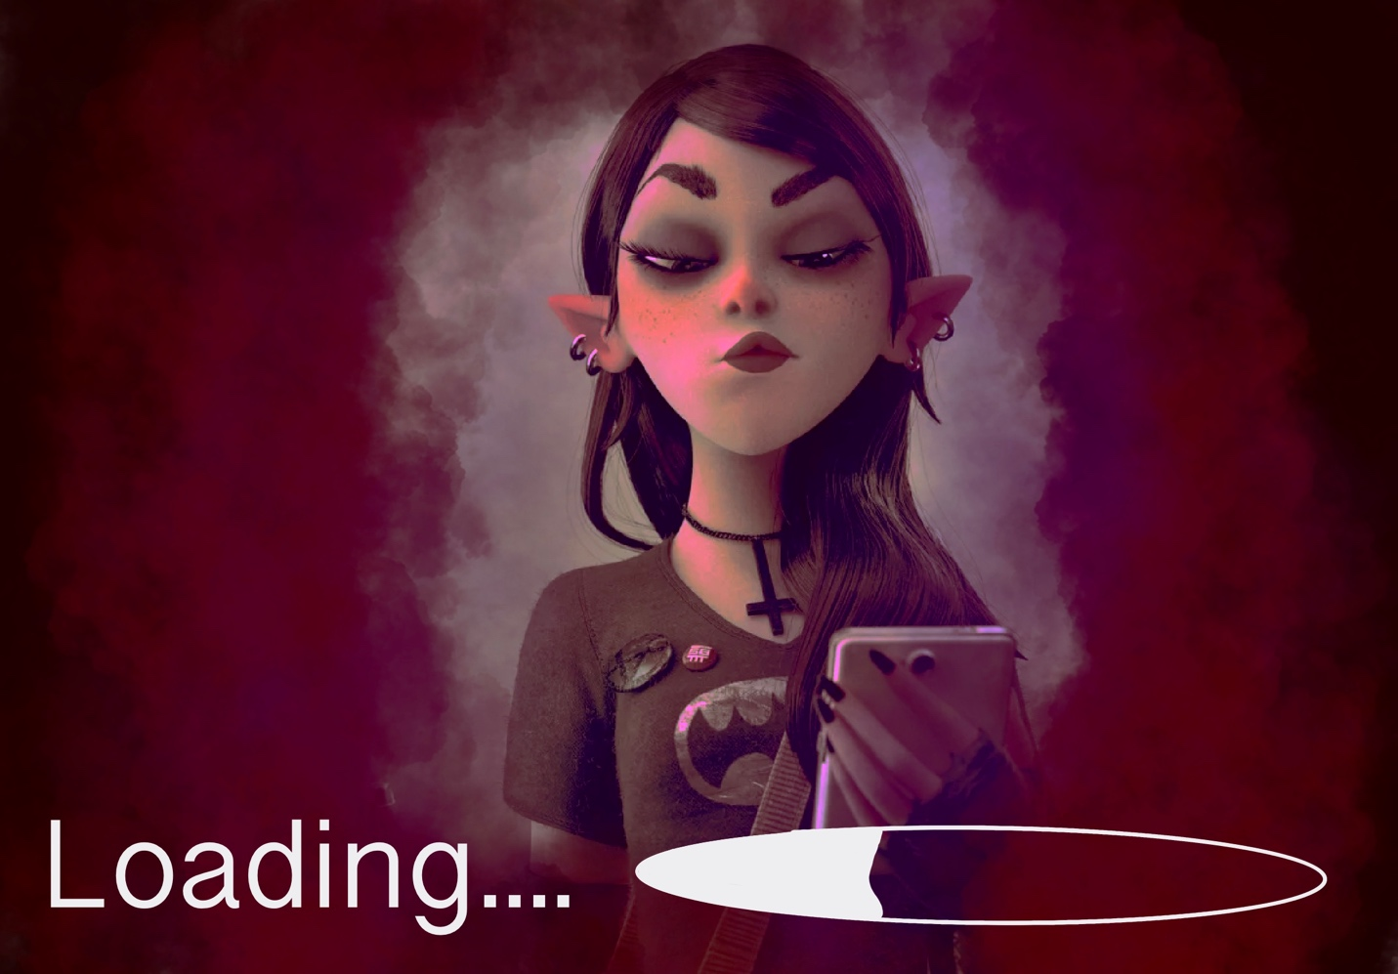

General enemy rules
Both the enemy and the character will have a health bar. Whoever reaches the end of the health bar first in battle loses. The enemy’s health bar size will range depending on difficulty of enemy or where the player is at in the game. For example, in the beginning of the game the small enemies will have small health bars and the towards the end of the game and the bosses will have higher health bars.

Level-specific enemies
Depending on the quest the player is completing the smaller enemies will change. The bosses however will be different each battle and contain different abilities for the player to attach. Some will have water abilities, some will have fire abilities, etc.

Bosses
There will be six total bosses. The first boss will be water based. The second boss will earth based. The third boss will be fire based. The fourth boss will be air based. The fifth boss will be disaster based will all elements and the final boss will be Lethia’s mental illness.

Minigames, if applicable
There will be a minigame in each level to complete. They will all vary between actual base quests lines and options for rewards. Some ideas in mind would be games such as space invaders against the game’s main small enemies or each a pacman based design.

Cutscenes
There will be cutscenes depicting the end of boss battles and in key gaps of Lethia’s story. A good example of a cut scene is in the gaining of the game with Lethia contemplates and attempts suicide.

Music and SFX
Music will be calm but dark throughout the game. When enemies appear or are near the music will become more violent and aggressive. The boss battle music will be drastic and chaotic.

Works Cited/Glossary
1. Sally Face
2. Alice: Madness Returns
3. Life is Strange
4. Tell Me Why
5. Portal 2

References

Sally Face. (n.d.). Retrieved December 4, 2022, from https://portablemoose.com/
Wikimedia Foundation. (2022, November 26). Alice: Madness returns. Wikipedia. Retrieved December 4, 2022, from https://en.wikipedia.org/wiki/Alice:_Madness_Returns
Square enix. Life is Strange: True Colors. (n.d.). Retrieved December 4, 2022, from https://lifeisstrange.square-enix-games.com/en-us/
Xbox Game Studios & Dontnod Entertainment. Tell Me Why. (n.d.). Retrieved December 4, 2022, from https://www.tellmewhygame.com/
Wikimedia Foundation. (2022, November 22). Portal 2. Wikipedia. Retrieved December 4, 2022, from https://en.wikipedia.org/wiki/Portal_2

